**Task 4: Establish a new directory, populate it with script files, initiate an empty repository on GitHub, convert the local directory into a Git repository, and link it to GitHub for pushing the code into the repository.**

***Create directory:***

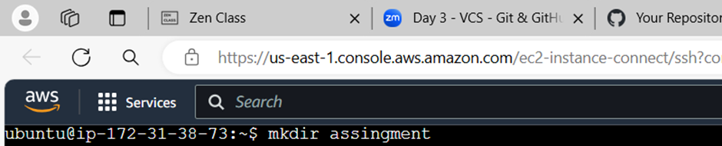

***Script files:***

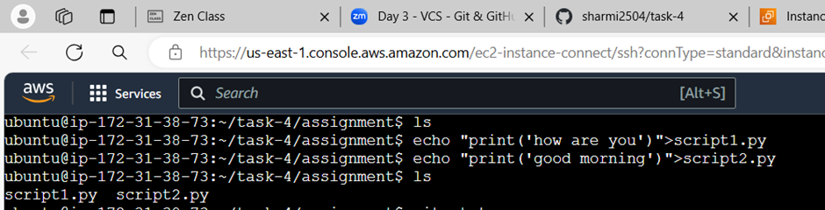

***Initiate empty repo in github:***

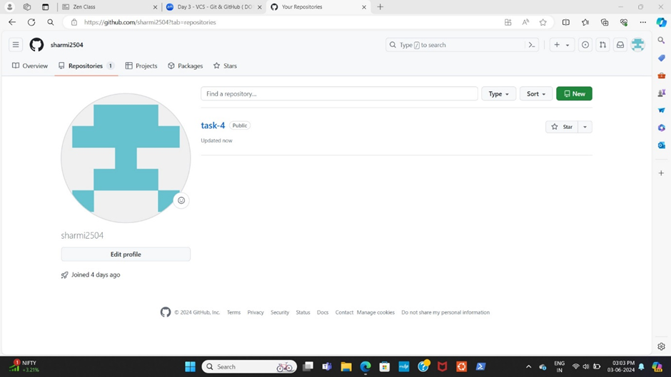

***Clone repository in local machine:***

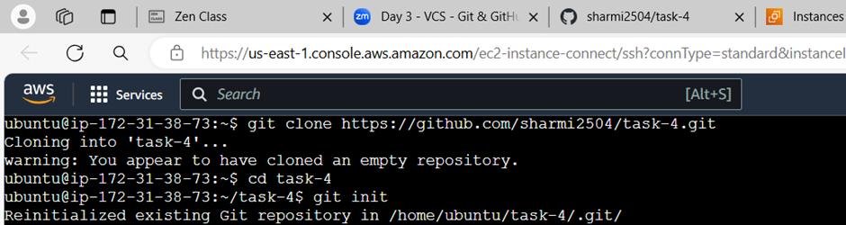

***To add and commit the script files:***

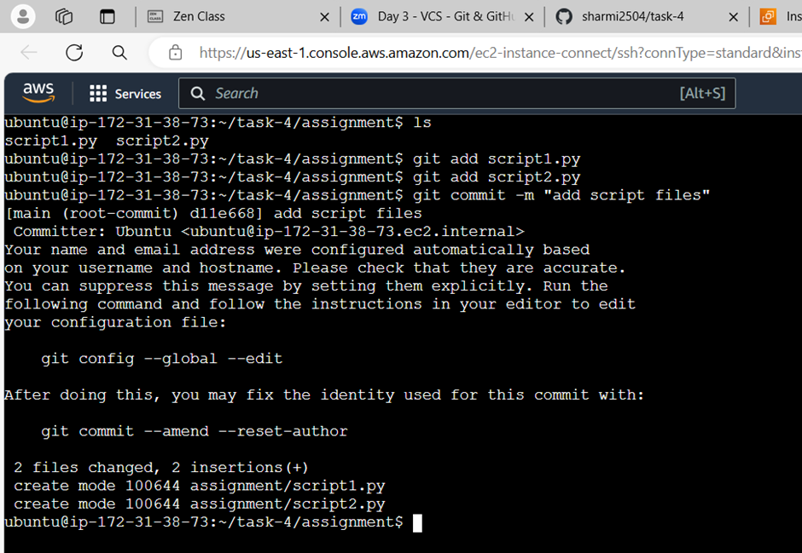

***To establish the connection between local repository to remote repository and push the code into repository:***

